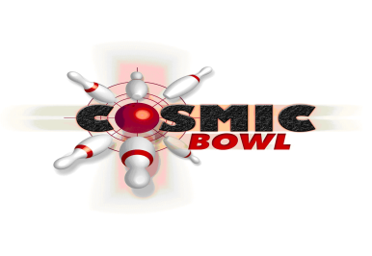
Dear Parent/Guardian
Thank you for choosing Cosmic Bowl to hold your child’s special day. Here are a few helpful tips on How to Get the Most out of Your Child’s Party:
BEFORE
- Minimum of 6 guests.
- We require a £25 deposit to secure your booking. This deposit is non-refundable. The party requires to be paid in FULL one week before the booking date. This is also non-refundable, however, if you have to change any details of your booking, please contact in advance of the party and we will be happy to help.
- We provide invitations. Please collect these when you pay your deposit. Alternatively, we can post invitations to you at no additional cost.
- If any party guests have dietary requirements, it would be helpful to inform us in advance of the party date.
ON ARRIVAL
- Please ask your party guests to arrive 10mins before the party booking time. This ensures the party starts at the time booked
- Please report to the Cosmic Bowl Reception, where a member of staff will meet and greet you.
- If you have brought along a birthday cake, please pass it to a member of staff at reception.
- When all your guests have arrived any remaining balance of the party is payable (if extra guests arrive) and your party can get underway.
- A member of staff will ensure the children are escorted to the lanes, their names entered, bumpers and or/ramps in place, if required, and take the food order
DURING THE PARTY
- Parents are asked to supervise the children during the party. We recommend one adult for every 6 children.
- Food will be served upon completion of bowling at a table, which has been reserved for your party.
- If you have provided a cake, a member of staff will bring this to the party table and encourage the children to sing “Happy Birthday”. A member of staff will be happy to cut the cake on your behalf for the children to eat or take home.
- Junior party guests are supplied with party bags. These consist of a packet of crisps, small bag of sweets and a lollipop.
- The birthday child is presented with a Day Pass Voucher for M&D’s Theme Park – redeemable at any time and all party guests receive 1 free game of bowling voucher.
- Should you wish to purchase any additional food or drinks during your party the Sports Bar (located within Cosmic Bowl), Family Restaurant or Wimpy will be happy to assist you.
- Cosmic Bowl also offer “Cosmic Combos” if snack food is required for the adults. The platter consists of wedges, nachos, chicken popcorn, onion rings, mixed pakora and dips.
AFTER THE PARTY
- Please leave the tidying up to us.
- You will be asked to complete a short questionnaire so we can monitor the standard of our parties.
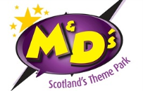
- Should any aspect of your party not meet your expectations please speak to the duty manager or staff member in charge of your party who will try to resolve this matter right away.

